Turker Script for Scenario 92

Scenario name: Turk Talk Test
Scneario URL: http://demo.openlabyrinth.ca/webinarmanager/progress/92
Map name: Hybrid NLP test
Map URL: http://demo.openlabyrinth.ca/labyrinthManager/global/606
Expected number of users: 4

Topic: chest wall pain
Learning objectives: (might be in the description or derived from metadata)
Description: (from Details page, Description field)
Testing the Scenario Director's ability to redirect a User according to their free text input. Human-hybrid NLP. Seems to work quite well. Only problem so far is that Visual Editor may drop the Hidden attribute on Links when you re-edit. Using Turk Talk approach for Initial Dx and Final Dx.
Shortcut phrases:
- be more specific
- please expand on that
- I'm sorry. I don't understand
- That's pretty close
- Please stop typing & read carefully
- Sorry to keep you waiting
- .
- .
- .

Visual Editor map:

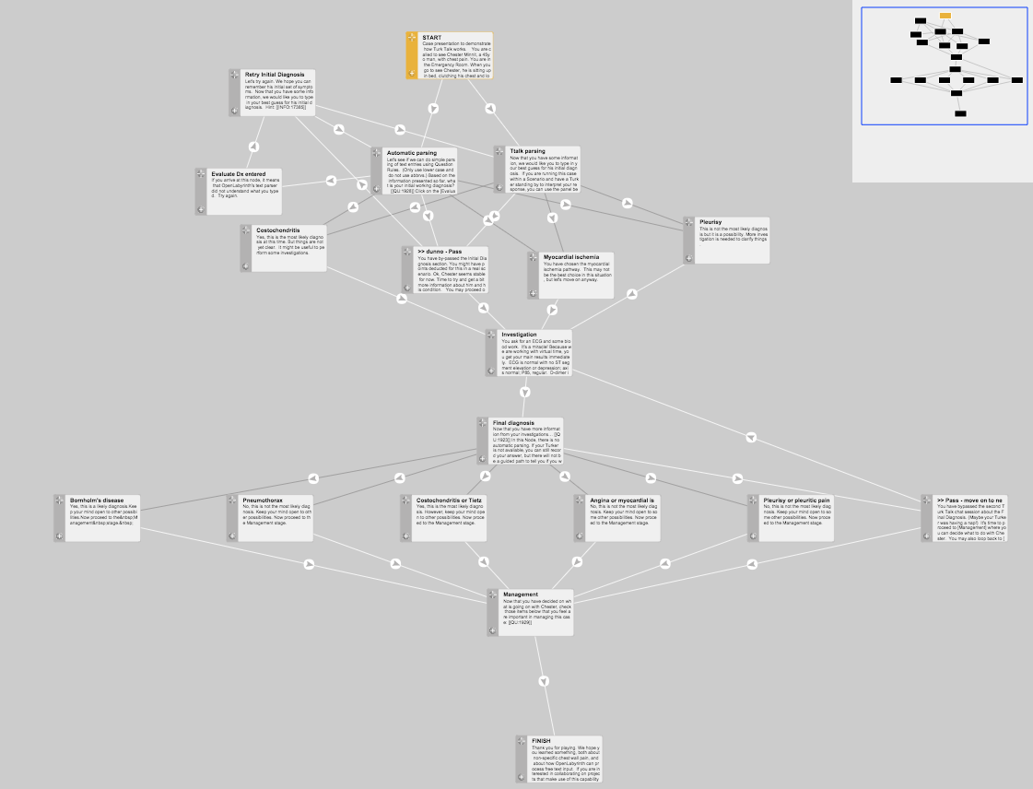
Turk Talk nodes:

1. 'Ttalk parsing', http://demo.openlabyrinth.ca/renderLabyrinth/go/606/17366 -

Table of possible responses:

Node ID | Title | Acceptable | Unacceptable | Notes
17369 | Myocardial ischemia | ischemia, angina, acute coronary syndrome, ACS | MI, infarct(ion), heart attack
17370 | Pleurisy | Pleuritic, pleural inflame/rub/effusion | Pneumonia, pneumothorax
17371 | Costochondritis | Chest wall pain, Tietze’s syn, Bornholm’s dis, | Torn muscle, shingles
17367 | Dunno – pass | - | - | Default if they skip

2. ‘Final diagnosis’, http://demo.openlabyrinth.ca/renderLabyrinth/go/606/17373 -
Node ID | Title | Acceptable | Unacceptable | Notes
17377 | Myocardial ischemia | ischemia, angina, acute coronary syndrome, ACS | MI, infarct(ion), heart attack
17378 | Pleurisy | Pleuritic, pleural inflame/rub/effusion | Pneumonia,
17376 | Costochondritis | Chest wall pain, Tietze’s syn, | Torn muscle, shingles
17374 | Bornholm’s disease | Bornholm’s dis
17375 | Pneumothorax |  | pneumo
17367 | Pass | - | - | Default if they skip

